Bot-Masters Progress Report 7/98-12/98
Prepared by Dave Warner MD 1/99

Program Summary

The Bot-masters program focuses on development of a universal wearable interface system which may be integrated into a variety of operational systems. The initial focus of this effort has been divided into two main areas, 1) to develop an enhanced sensory capacity for the user of a standard issue landmine detector, and 2) to develop a more generalized capacity to address the interface issues of human-computer interaction requirements for field operability of wearable computer and communication systems for the purposes of controlling distributed robotic systems.

In the area of landmine detection, we began by becoming familiar with the current systems and their operational functionality. For this work we first acquired a standard issue mine detection system, the pss12, to evaluate the possibility of enhancing the user interface. To ensure developmental realism we have worked with Marine Corps System Command in Quantico VA.

Our research into the operational parameters of the pss12 mine detector was aimed at identifying areas where we could enhance the functionality of the system without redesigning the whole system. The audio output was evaluated along with the coil function. While some refinement in the audio display and coil function was determined to be possible, these refinements were not seen as significant enough to warrant further development of the current system at this time.

More recently our efforts have been directed at developing an interface system for the NQR mine detection system being developed by Quantum Magnetics. The challenge here is to develop a system which aids the user in optimizing the use of this new system. Both the weight of the system and the change of the behavior of the human from continuous to discrete scanning have been the biggest challenge.

In the area of wearable computer interface systems our efforts have been to develop a robust set of human-to-computer interfaces which are integrated into a single system. For this project we have developed a set of wearable input devices which allow a human operator to have a variety of options for interacting with control parameters of the distributed robotic systems.

We have developed and tested several new wearable input devices and have successfully integrated them into a single interface system.

Technical Progress

Task 1 - Planning

Our planning efforts were guided by two primary issues, the needs of the user and the operational functionality of the technology. We have also spent a significant amount of time with a wide variety of potential users of our systems in order to gain insight into the specific problems which need to be addressed. We have determined which aspects of the interface development are the most universal, and have developed a core technology which can be adapted to a wide variety of applications. It is our understanding that the specifics of the application will evolve dynamically as our sponsors needs shift and as our technology evolves.

Task - 2 Evaluating current standard issue landmine detector

We acquired a standard issue landmine detector (PSS-12) for evaluation. In our evaluation of the system we focused on the understanding the functionality of the system in order to identify areas which could be significantly enhanced by the development/refinement of the user interface. Specifically ways that will increase the perceptibility of signal features indicating the presence of a landmine. For our evaluation we were given several standardized mine simulators. We were given an orientation to the system by the Marines as to how the system is used, when it fails and why. Our evaluation identified three potential areas for enhancement to the system. The audio output, the coil function and the user control of any modifiable parameters.

Task -3 Enhance the current audio output of detector

From our initial evaluation of the PSS-12's audio output it was recognized that the "signal" which indicated the presence of potential landmine (ie the presence of metal) was encoded in the intensity. That is the way that the user is alerted to the threat is the signal gets louder. This turned out to be hard wired by the PSS-12's internal electronics and is directly related to the change of current in the induction coil. The audio signal was found to be non-liner and the design of the overall electronics makes it prohibitive to make any fundamental change to the nature of the audio output

Task -4 Processing raw data coming from the coil

We explored methods of acquiring and modifying unprocessed signals coming directly from the induction coil. This proved to be of limited value due to nature of the PSS-12's integrated system. After discussion with out counterparts at Duke Univ. NC. which have extensively evaluated the system electronics it was determined that the level of effort needed to significantly improve the current system would not be justified. It is our conclusion that the data coming form the coil, in its native form, does not contain information which can be extracted by enhancing the signal processing of the data.

Task -5 Modifying the detector coil function

The PSS-12 has a fixed coil function. The proprietary nature of the system prohibits any major modification of the present system with respect to coil function. However our research indicates that there is a potential benefit to develop a coil function which varies the electric current and signal intensity as a function of time.

Task -6 Methods of user interaction with any modifiable parameter

The PSS-12 has 2 modifiable parameters, sensitivity of the coil and intensity of audio output. Currently the controllers are mounted on the electronics case and are not ready accessible to the user should they need to fine tune the system when in an operational setting. To mitigate this design and to anticipate the development of other user modifiable parameters which may be developed for the emerging class of handheld mine detectors we have concentrated on rethinking the user interface in general. The first project was to bring the controllers onto the handle of the device it self. To do this we first prototyped a series of different handles.

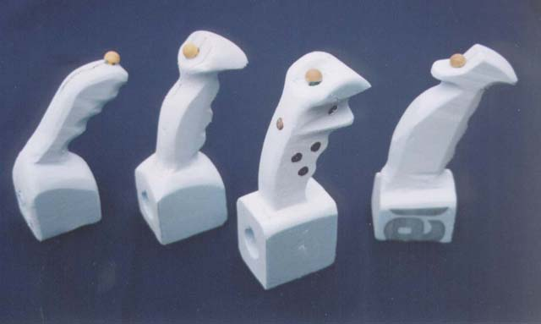
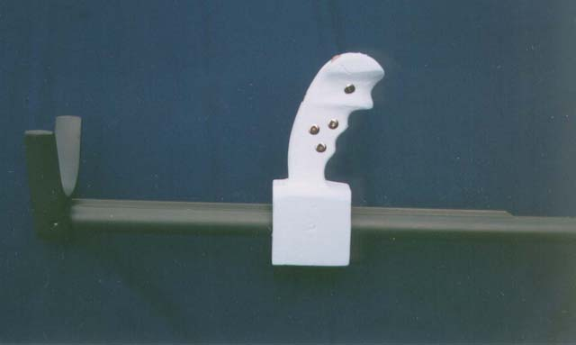
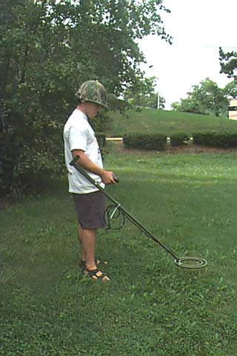
We then placed the handles on the PSS-12 and tested the "feel" and form with several individuals to determine the best fit.
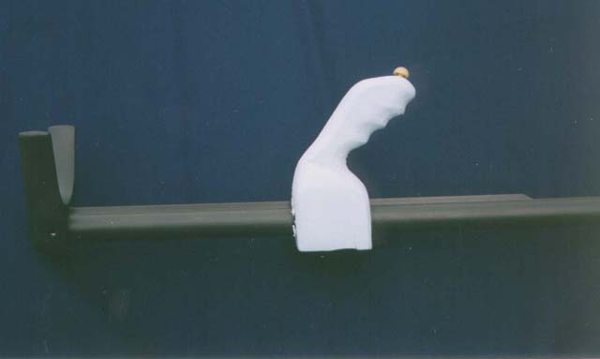
After our initial testing of handle mounted control parameters it occurred to us that it would most likely be desirable to also add some output functionality to the handle. We then prototyped a "multimedia" handle which added a visual and vibrational component to the system.
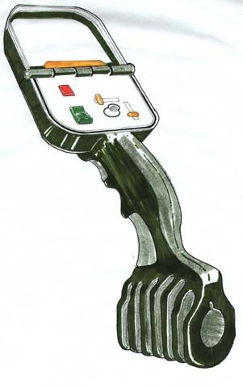
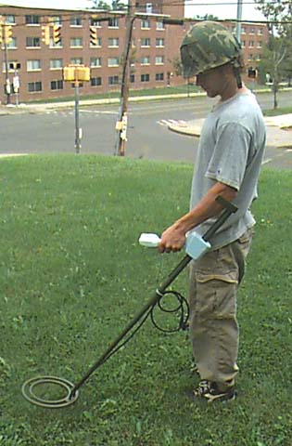
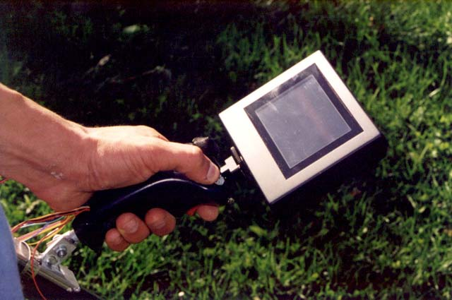
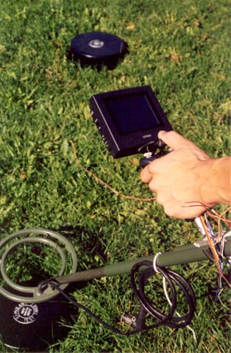
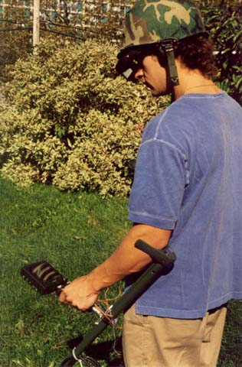
After initial user testing of the form we developed an operational prototype of the multimedia handle with the visual display and vibration alert system.

For output of the visual display we developed a audio to graphic software tool which allowed us to take the standard audio output of the handheld mine detector and run it through a computer and display the data in a visual format

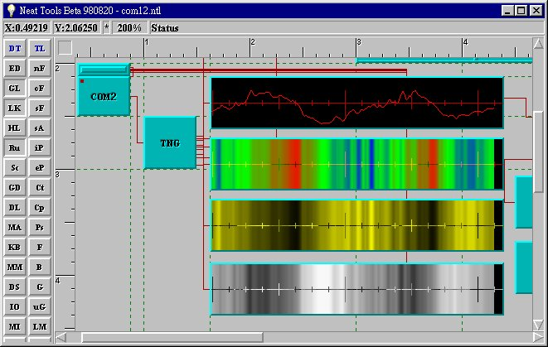

We demonstrated the functional system to the Marines and to the DARPA Pm.

We were then directed to devote the remainder of our efforts in the landmine work to developing an operational interface to the NQR mine detection.

The NQR mine detection system being developed by Quantum Magnetics in San Diego. We have had several meetings with the developers and are currently working on the user interface. We have evaluate the specific issues which are unique to the NQR system and have begun to develop the system.

In the case of the user the NQR system we have had to overcome two significant hurdles.
First we need to develop a harness so the human user can use the system for a reasonable amount of time before getting tired. (The current system has a 10lb scan head that must be held above the ground in a steady manner at the end of a 4 foot rod.) The second hurdle is that we need to develop a device/system which can accurately track the position of the scan head with respect to the position of the user.

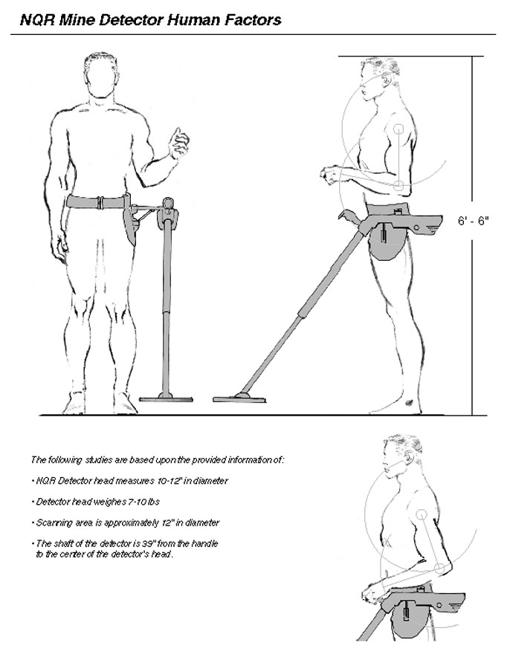

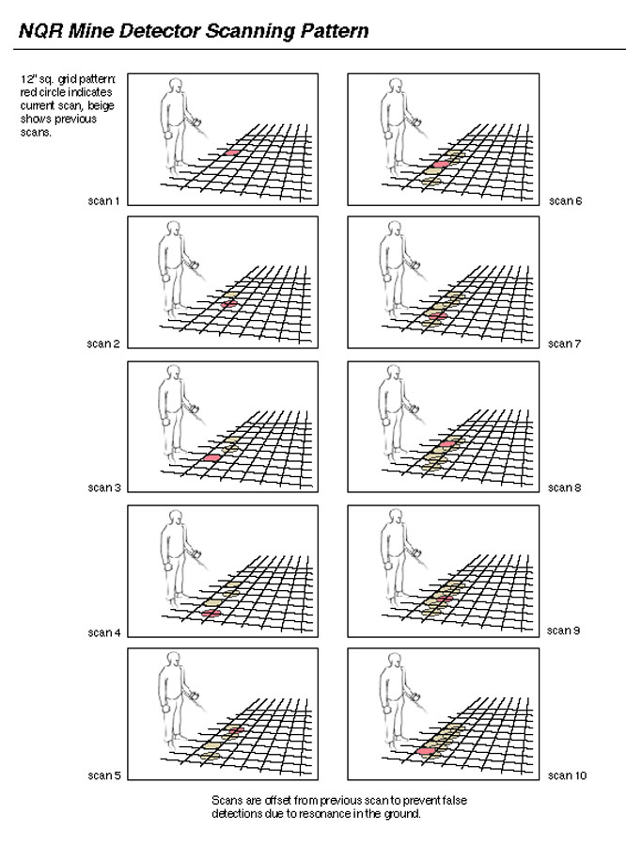

Task -7 Field testing and user input

While we continue to get user input to help our ideas, actual field testing will begin in March 99

Tasks 8-12 are to be performed in FY'99
Task -8 Non-traditional display methods-

Task -9 Evaluation of non-standard mine detection sensors

Task -10 Exploit the data from these new sensors

Task -11 Modular electronic components integrated with body worn computational and communication device

Task -12 Human interfacing to emerging technologies

Task 13-- INTEGRATION AND FUSION

Our efforts for this task have been the integration and fusion of information from multiple human-to-computer input devices into a single wearable interface system. We have successfully achieved the integration of several data input devices into a single system. Devices such as, bioelectric signal detectors, dynamic bend sensors, pressure sensors, and audio inputs have been integrated Our system also supports input devices such as mouse, joystick and keyboard. We have successfully integrated several input systems which will allow the user to have a multiplicity of simultaneous interaction options.

Subtask 13A -Planning

We have developed a plan which guides our design and development. We will proceed with the development of a hardware and software system which has an open architecture and anticipates a wide variety of data input devices. Our software development will continue to be multithreaded multitasking and will be object oriented.

Subtask 13B - demonstrate an interactive interface which can simultaneously read data from multiple, wearable human to computer input devices.

We have successfully demonstrated the ability of our software to be able to simultaneously take data streams form several wearable input devices.

Subtask 13C -acquire and integrate a set of human to computer input devices into the wearable interactive interface system

We have acquired and/or developed a set of wearable input devices which have been integrated into our system. These devices include:

Pressure sensors which may be placed in gloves or in the shoe insole (or any where else they are desired on the body.

Bend sensors which encode the articulation of joints such as finger, wrist, elbow, neck, knee and ankle.

Bioelectric sensors which sense the electric field generated by myo-electric activity (muscle)

Four-position switches so directional control can be effected by one finger.

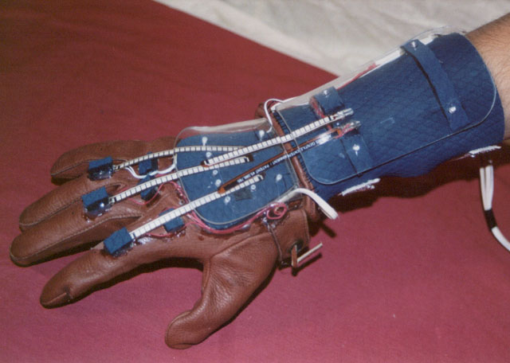
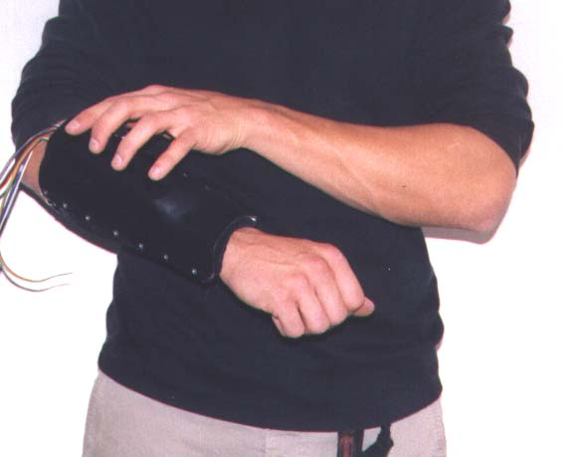
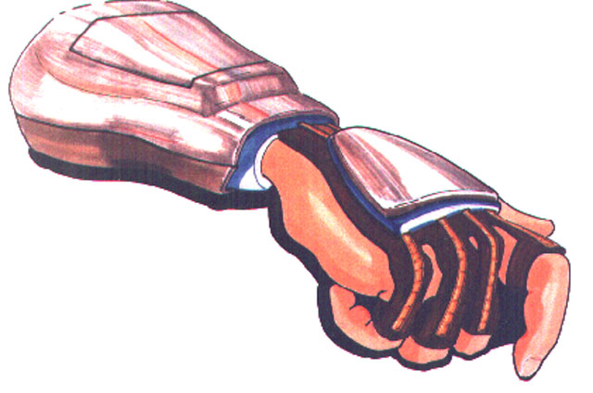
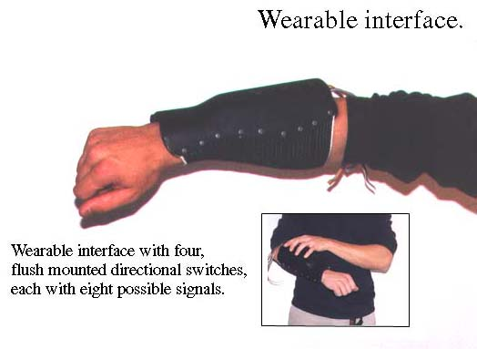
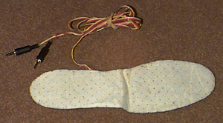
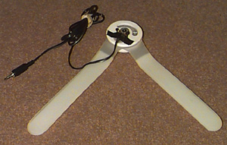

Subtask 13D- demonstrate the capacity for filtering and combining data streams from the various body worn human to computer input devices

We have developed software modules which allow for the mathematical filtering of data streams. To do this we developed a general software tool which we can configure of perform functional operations on data streams for any desired purpose. This development is a powerful tool for rapid-prototyping new filtering techniques.

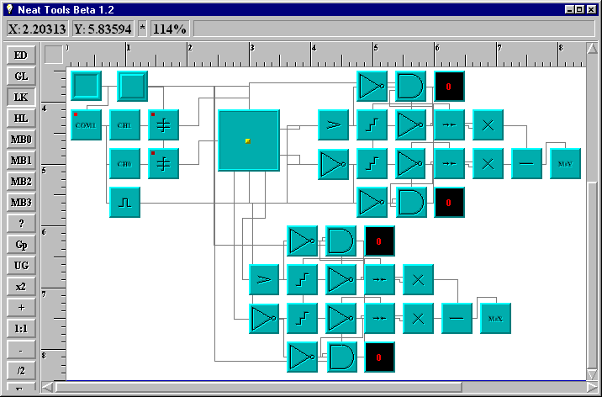

Subtask 13E -demonstrate the capacity for developing user defined gestures

We have successfully demonstrated the capacity to define various values of incoming data from the wearable input devices. We also have developed a method for identifying a value or set of values which can be combined to initiate some output function. This user defined gesture function was designed to be able to be configured in the field, on the fly.

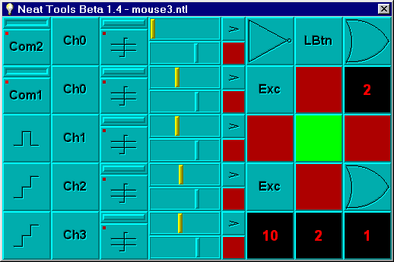

Subtask 13F -Demonstrate an integrated, operationally functional human to computer interface system which allows for the simultaneous input from several human to computer
interface data streams

We have successfully integrated the functionality of reading multiple data streams form multiple input devices in a way that data streams from different devices can be combined to form user defined gestures.

We have successfully completed all the subtasks for TASK 13. Current efforts are focused in deploying this developed functionality into a wearable air ground station.

Task 14 - Develop a wearable air ground station
To be done in FY'99

Task-15 Experimental protocols

We have interacted with the technology developers involved in supporting DARPA's wearable computer and communication program. Based on feedback from these interactions we have begun early testing of the usability of our interfaces. This systematic evaluation will continue to occur throughout the program.

Task 16 Demonstrations

We have and will continue to provide support for demonstrations of the developing functionality. These demonstrations will take place at the appropriate DARPA PI meeting and other places as required.

Task 17 Reporting

We have and will continue to deliver copies of technical documentation as they are requested.

We also have developed a web-site where ongoing work in progress may be reviewed.

Problem areas identified.

The PSS-12 mine detector is a closed system of proprietary electronics. Any attempt do enhance any of its basic functions such as coil function or audio output would not be practical. The system was designed to be a simple yet robust metal detector. In order to do any meaningful enhancements to the system would require an open system which could be modified at the component level. And while it is the "standard" currently deployed it is our opinion that the basic functionality of a single "signal" coil is fundamentally limited in its capacity for significant improvement in performance.

The research done on the PSS-12 handheld mine detector has brought to light a fundamental issue with that type of mine detection system. That is the fact that there is no way in the current system to retain the information gained by the sensor for the purpose of integrating it with the position of the sensor. We are attempting to mitigate this problem in the development of the interface system for the NQR mine detector, by developing a head tracking system. It is our belief that such a head tracking system for the PSS-12 may profoundly increase the utility and reliability of that system. If such a system were developed then the user could iterativly scan an area and create an image from the data over multiple scans of an area.

Problem areas involving cost

Our project is on schedule and at cost as far. One note is that due to the nature of this project a significant amount of travel has been and is projected to be required. To date there have been over 10 trips to the Washington DC area, 5 trips to San Diego, 3 trips to Boston. This has substantially exceeded our original estimates for travel expenses. We have adjusted our work schedule to accommodate this.

Equipment and staffing

We have acquired the necessary equipment and staff to proceed without any major delay

Bot-Masters

Technical POC. Dave Warner MD

Dr. Dave Warner ,
2-212 Center for Science and Technology
111 College Place
Syracuse NY 13244-4100

315-443-5654 voice
314 443 1973 fax
800 950 0849 pager w/voice mail
davew@npac.syr.edu

