APPLICATION OF THE “PENGUIN” SUIT FOR
REHABILITATION OF THE CEREBRAL PALSY PATIENTS

Since 1971 the “Penguin” suit has been used on board the Russian orbital stations for creating axial loading and compensating support and proprioceptive deficit, as countermeasure against muscle and bone disorders induced by long-term exposure to weightlessness. In the 90th were initiated studies on introduction of the “Penguin” suit into clinical practice for treating motor and speech disorders, in particular, for cerebral palsy (CP) conditions.

Traditional CP treatment is mostly of the static character, limiting muscular function, without involving proprio- and support reception. Fixation of the individual segments simultaneously arrests the whole muscular-skeletal system; such a static condition with non-functioning neuromuscular apparatus produces a negative effect.

Cerebral paralysis in the residual stage is insufficiently treated by the traditional conservative and surgical methods. Our data show, that, in spite of the repeated courses (on the average, 9 courses of treatment per patient), the deformity of spine remain in 35% of cases, deformity of the upper limb - in 25% of cases; of the hip joint - in 34% of cases; of the knee joint - in 27% of cases, and of the ankle joint - in 60% of cases, aggravating orthopedic and neurological conditions in many patients.

Traditional CP treatment is particularly insufficient for young children, as, in part of the patients, the effect achieved for the certain level of the muscular-skeletal system wears-off because of the continuing pathology process, and in some patients the pathology becomes even more sever.

Contemporary method of the CP treatment utilizes multiple effects on the whole neuromuscular system by applying special “Penguin” suit for the dynamic proprioceptive correction (DPC). The “Penguin” suit has 22 shock adsorbers (see Fig. 1) that can create various tension for the various segments of the muscular-skeletal system, inducing improved afferent input into the central nervous system; and decreases or totally removes flexion attitudes and contractures.

Indications for the DPC treatment are as following: a) hyperkinetic, b) spastic, c) hemiparetic, d) atonic-astatic forms of disease, some after-effects of the closed craniocerebral injury with marked paresis and preserved or insignificantly decreased intellect. Contraindications for the DPC treatment are marked orthopedic pathology, spasmodic or pain syndrome with marked disturbance of the intellect.

The DPC treatment affects the central nervous system, normalizing the afferent input and increasing the intensity of the discharge owing to the active mechanical impact on the proprioceptors of the trunk and lower limbs. The DPC treatment improves electroencephalogram (EEG): in 28% of cases the EEG approached the standard, the amplitude of the basic cerebral rhythm was increased in 34.7% of cases, decreased epiactivity was registered in 58.3% of cases.

A single session of the DPC is determined to be up to 1 hour per day, required duration of the whole course of treatment - 20 days for the primary patients, and potential limitation of the repeated courses to 10 days.

A single application of the “Penguin” suit leads to alterations in the individual profile of interhemisphere asymmetry (see Fig. 2), that can be related to loosening of the initial spatial-posture stereotype. In combination with the data on characteristic sustaining of the upright posture and biomechanics of gait before and after the FDPC treatment, the former fact can be an evidence of the sufficient brain plasticity in CP patients and of the possibility to reconstruct nervous links in the central nervous system owing to the increase in somatosensory afferent input induced by an application of the “Penguin” suit.

Stabilography tests in the “Penguin” suit revealed considerable increase in stability and significant decrease of all the stabilography parameters, more, than twofold (see Fig. 2) The increased stability was retained after cessation of the DPC treatment, the controlling role of the visual analyzer over the upright posture approaching normal values in the CP patients.

Evaluation of the baseline and exercise energy expenditure with and without suit confirms positive effect of the DPC treatment, which decreases energy expenditure while walking (by 15%) in all the CP forms, and, especially, in the hyperkinetic form.

Positive effect of the DPC treatment varies with the various CP forms. The hyperkinetic, spastic diplegia, hemiparetic and atonic-astatic forms respond by improvements in stabilography parameters and in gait biomechanics, increased muscle strength, decreased spasticity and improved EEG. However, those improvements are mostly marked with the hyperkinetic form and spastic diplegia. With the hemiparetic form the improvements are less, and with atonic-astatic form the improvements become significant only after repeated courses of the DPC treatment. The DPC treatment of the most severe cases, that do not respond to other methods of treatment, enables to relieve their condition and improve their capabilities and social adaptation.

Application of the “Penguin” suit enables to achieve stable positive effect in shorter time than traditional methods. The results show that the DPC method reduces duration of the hospital treatment for 12 days, on the average. The requirements for physical therapy procedures and medical preparation also significantly decrease. Economic expenditure of the DPC treatment is by 41% reduced in comparison with the traditional methods.

Fig. 1
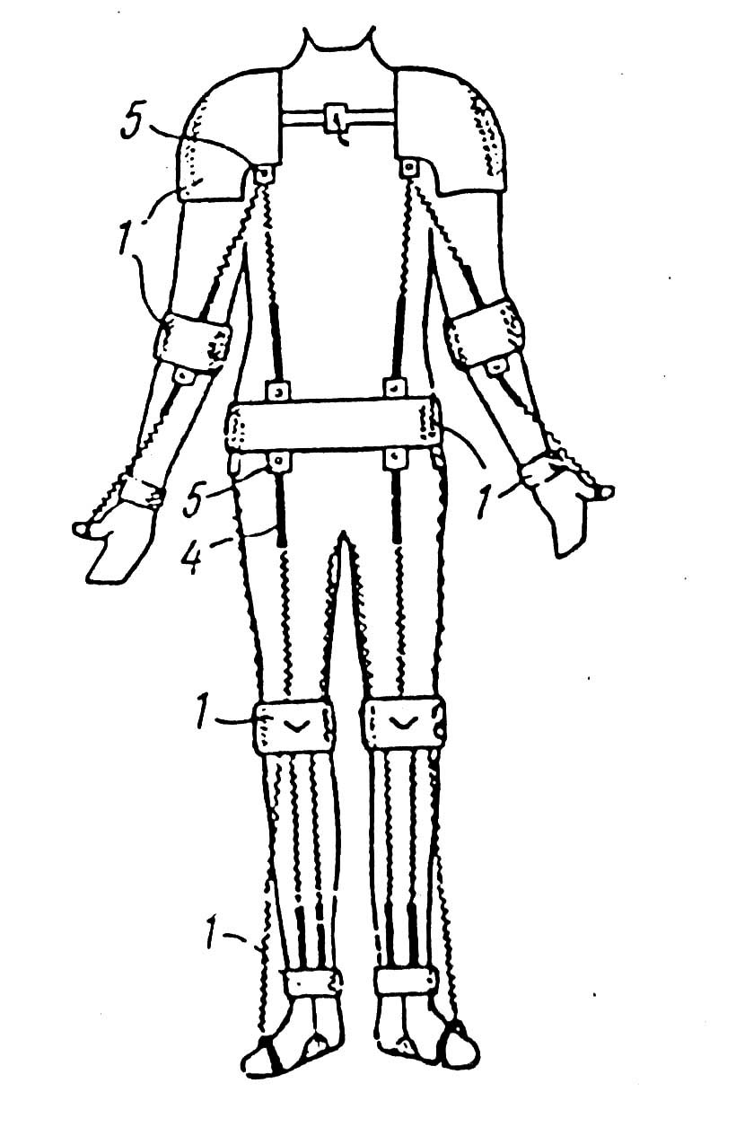
Penguin suit consists of the shoulder, genicular, foot, anconal, carpal and finger supports (1) interconnected by the fastening elements.
The fastening elements consist of elastic links (2) and are located on the surface of the patient’s body in antagonistic pairs depending on the anatomic location of the skeleton musculature. Each link (2) is connected with two supports (1) and comprises a regulator (3) of its tension mounted between the link (2) and one of the supports (1) by means of lock.

Fig 2

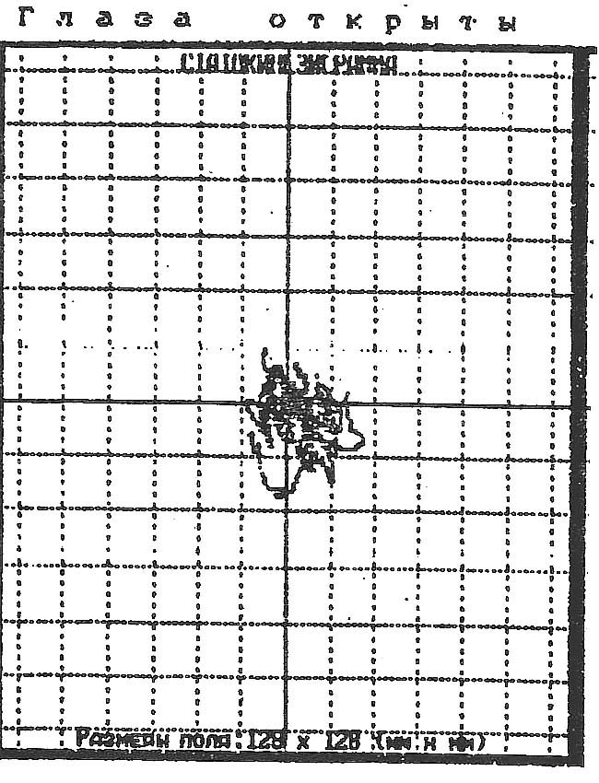
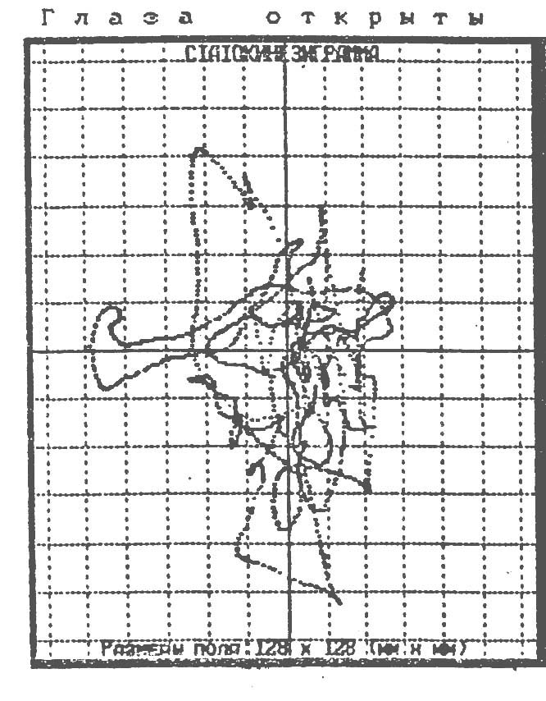

Statokinezogram (testing of stability) before (on the left) and after (on the right) the DPC treatment by “Penguin” suit
(Patient with atonic-astatic CP, age: 15 yrs)

