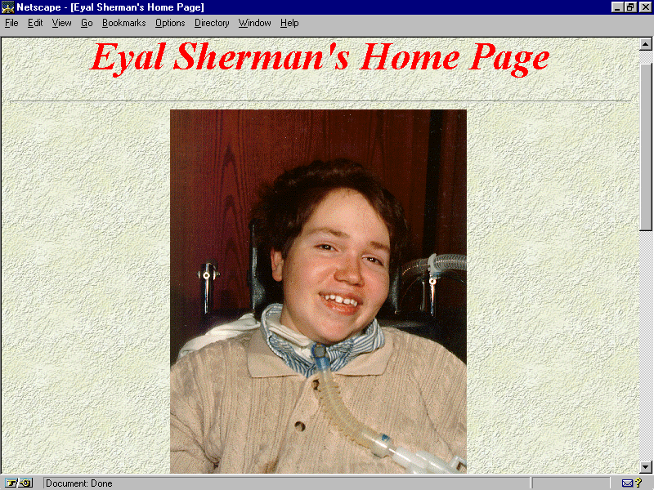
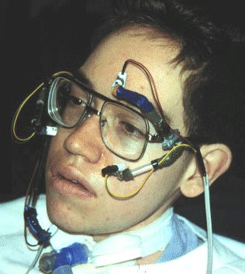
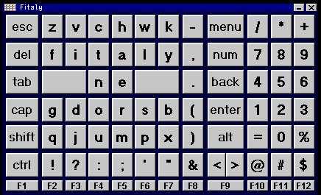
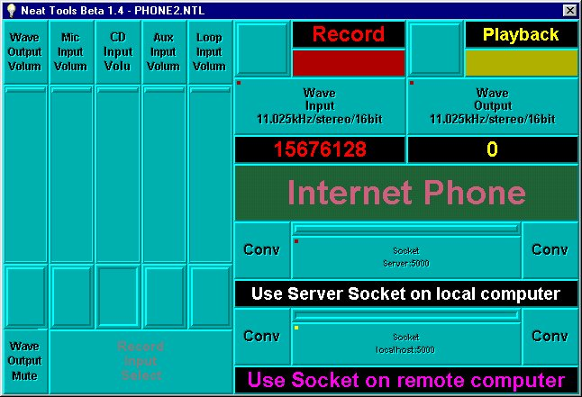
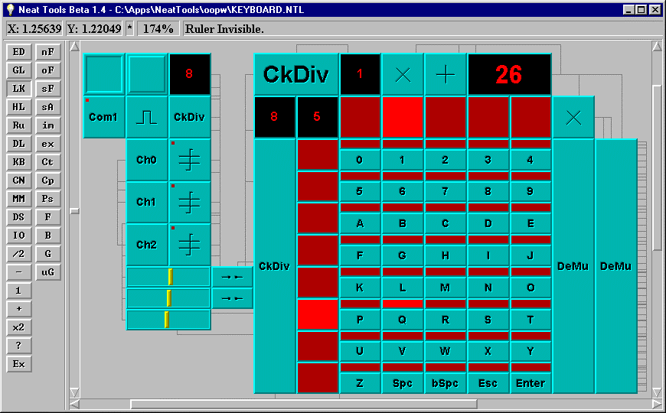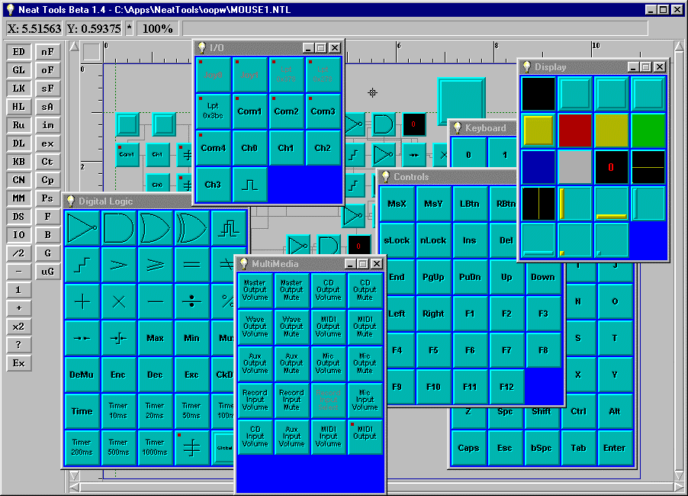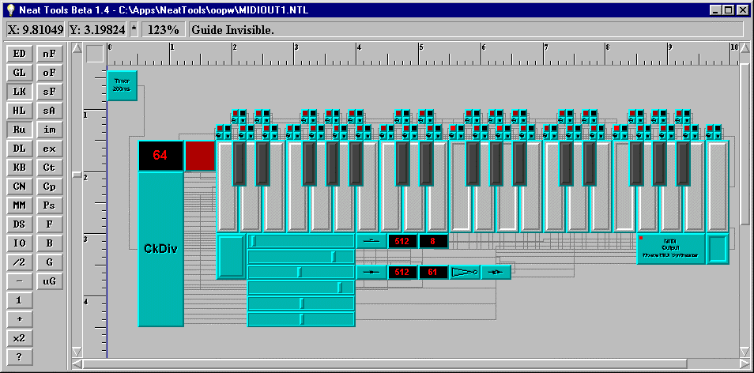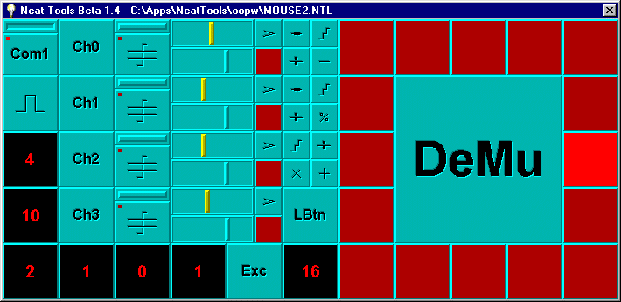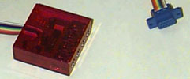
1
2
Fig. 1. www.npac.syr.edu/projects/neattools/Eyal/
Fig. 3. Sensor (photocell) mounts on eyeglasses.
Fig. 2. TNG-2 interface module & serial cable
(4 analog inputs via 1/8" stereo plugs).
Fig. 4. NeatTools showing object toolboxes.
Fig. 5. NeatTools piano (autoplayer or manual modes) with sound control sliders.
Fig. 7. Keyboard matrix prototype (row/column select; keypress).
Fig. 6. Four-channel mouse prototype (mouse direction, here “east”; motion; & click). Yellow meters indicate signal strength. Blue sliders set threshold for assertion (CW, CCW rotation of selector at settable speed; go/no-go; click). Note that editing environment has been optionally hidden for naïve users (e.g. family members)..
Fig. 8. TextWare Solutions’ FITALY™ keyboard (actuated via NeatTools mouse driver)..
Fig. 9. Internet sockets (phone example with digital audio recording).
C–15

